3. Company Analysis
This chapter profiles the acquirer and the target. Sun Pharma is a profitable, net-cash, emerging-market-anchored generics and specialty company. Organon is a levered, US-anchored spin-off with a leading women’s-health franchise, a growing biosimilars unit, and a large but declining established-brands base. The two are similar in size (~$6.1–6.2bn revenue each) but opposite in balance sheet.

3.1 Sun Pharmaceutical Industries Ltd. — Acquirer
History. Founded 1983 by Dilip Shanghvi with five psychiatry products. Grew through acquisitions — Caraco (US), Ranbaxy (2015, ~$4bn), Taro, Pola Pharma, Concert. Now India’s largest pharmaceutical company and among the largest global generics players.
Business model. Two engines: (i) high-volume generics across the US, India and emerging markets, built on low-cost, vertically integrated (API) manufacturing; and (ii) a higher-margin global specialty franchise in dermatology and ophthalmology. Specialty is the strategic growth priority.
Segments and revenue mix. FY2025 revenue from operations ~₹520.4bn (~$6.1bn), +9% YoY. India-branded formulations and US generics/specialty are the two largest pools. API is a small, mostly captive segment.
Geographic mix. US ~30% of revenue; India ~32%; emerging markets ~17%; rest of world ~13%; API ~8%. US formulation sales were soft in FY25 (generic Revlimid erosion); India-branded grew ~13% and emerging markets ~10–14%.
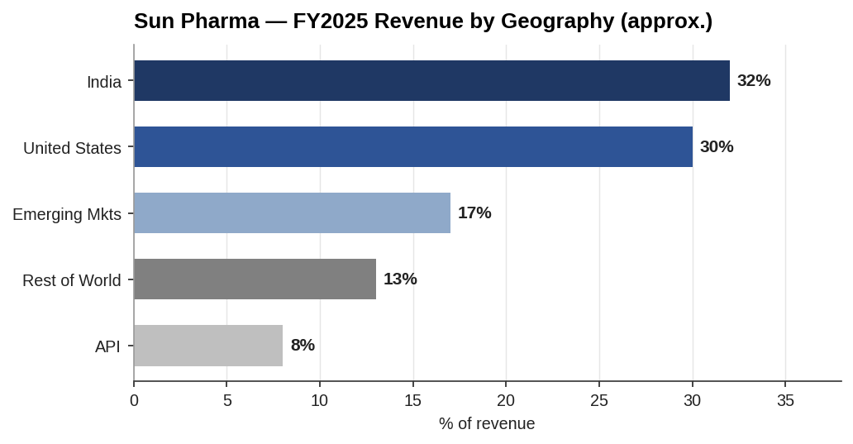
Sun Pharma revenue by geography
Key products.
Franchise | Products | Note
Global specialty | Ilumya / Ilumetri (tildrakizumab), Winlevi, Cequa, Xiidra, Odomzo, Levulan | Ilumya >$500m annualised run-rate; US specialty targeted high-teens CAGR to FY27
US generics | Broad ANDA portfolio incl. former Revlimid generic | Revlimid decline a FY25 headwind
India branded | Leading domestic formulations portfolio | ~No.1 by prescription share
Emerging markets | Branded generics across EM | Double-digit growth
Management and shareholding.
Item | Detail
Chairman & founder | Dilip S. Shanghvi
Managing Director | Kirti Ganorkar (since 2024)
COO | Aalok Shanghvi (appointed Feb 2025)
Promoter / promoter group | 54.48%
Foreign portfolio investors | ~17.5%
Domestic institutions | ~19.8%
Public / retail | remainder (~8%)
Governance is founder-controlled, one-share-one-vote, no dual-class. Promoter control removes takeover risk but concentrates decision-making.
Recent performance. FY25 revenue +9%; adjusted EBITDA ~₹153.0bn (~$1.8bn), margin ~29%; adjusted PAT ~₹120.0bn (~$1.4bn); EPS ₹45.6 vs ₹39.9. Net cash ~$3.1bn at 31 Mar 2025.
Competitive advantages. Low-cost, API-integrated manufacturing; scale in generics; a differentiated (rare for an Indian peer) global specialty franchise; net-cash balance sheet giving acquisition firepower; deep EM distribution.
Growth drivers. Specialty scale-up (derm/ophthalmology); India-branded volume; EM expansion; the Organon acquisition itself (biosimilars + women’s health + US scale).
Risks. US generic price erosion; regulatory (FDA plant inspections/warning letters historically); specialty concentration in Ilumya; integration and leverage risk from the Organon deal.

3.2 Organon & Co. — Target
History. Spun off from Merck & Co. in June 2021 as a standalone women’s-health-led company, inheriting a portfolio of mature Merck brands plus a biosimilars unit. Listed on NYSE (OGN). Independent since 2021.
Business model. Three franchises: Women’s Health (branded, defensible, growing), Biosimilars (fast-growing, price-competitive), and Established Brands (mature, cash-generative, declining). The established-brands cash flow funds debt service and reinvestment.
Segments and revenue mix. FY2025 revenue $6.216bn, −3% YoY. Established Brands $3.691bn (59%), Women’s Health $1.752bn (28%), Biosimilars $691m (11%). Adjusted EBITDA $1.91bn (30.7% margin). Adjusted net income $954m ($3.66/share).
Geographic mix. ~⅓ of revenue from the United States; ~⅔ international, spanning reproductive medicine, hormone therapies and established brands across Europe, Asia and Latin America.
Key products.
Franchise | Products
Women’s Health | Nexplanon / Implanon (long-acting contraception — the flagship), Follistim, NuvaRing, Jada
Biosimilars | Hadlima (adalimumab), Renflexis (infliximab), Ontruzant (trastuzumab), Brenzys
Established Brands | Nexium, Zetia / Vytorin, Singulair, Cozaar / Hyzaar, Arcoxia, Dulera
Management and shareholding.
Item | Detail
CEO | Joseph Morrissey (interim) — appointed Oct 2025
Former CEO | Kevin Ali — resigned Oct 2025 (see governance flag)
Ownership | Widely held; predominantly institutional; no controlling shareholder
Governance flag — CEO resignation and Nexplanon sales probe. In October 2025 CEO Kevin Ali resigned in connection with an Audit Committee investigation. The probe found that certain US wholesalers were asked to buy more Nexplanon than needed at the end of Q4 2022, Q3–Q4 2024, and Q1–Q3 2025 — i.e., channel-stuffing that pulled forward revenue. This is material: it casts doubt on the reported trajectory of the flagship Women’s Health product, is a diligence and representation-and-warranty issue for Sun, and is a live risk for the valuation and merger chapters.
Recent performance. FY25 revenue −3%; EBITDA margin held at ~31%. The 2025 dividend was cut sharply to prioritise debt reduction, which compressed the equity value and depressed the unaffected share price — context for the deal’s low equity cheque.
Competitive advantages. Nexplanon’s leadership in long-acting reversible contraception; global commercial and regulatory infrastructure; an established biosimilars platform; high cash conversion from established brands.
Growth drivers. Nexplanon lifecycle/label extensions; biosimilars launches (incl. high-value oncology/immunology); Women’s Health pipeline. Offsetting: continued established-brands erosion.
Risks. Secular decline of established brands (~59% of revenue); the Nexplanon sales-practice probe and related legal/reputational exposure; high leverage (~$8.6bn gross debt); US drug-pricing pressure; biosimilar price erosion; leadership transition.

3.3 Buyer vs Target — snapshot
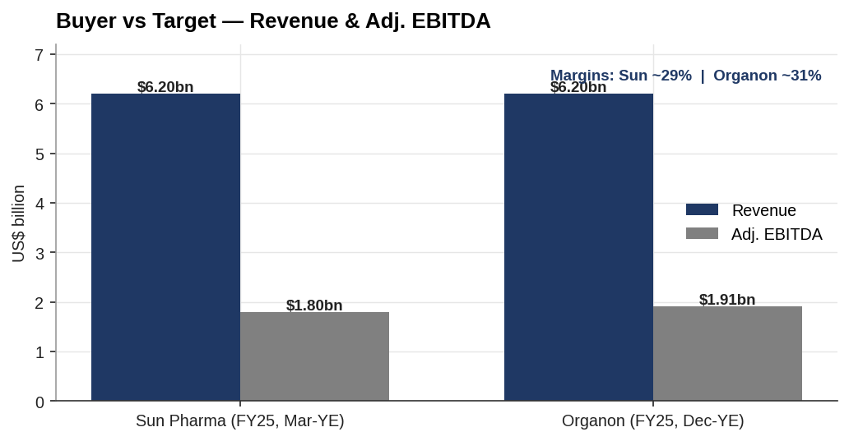
Buyer vs target — revenue and EBITDA
Metric (FY2025) | Sun Pharma (Mar-YE) | Organon (Dec-YE)
Revenue | ~₹520.4bn (~$6.1bn) | $6.22bn
Adj. EBITDA | ~₹153.0bn (~$1.8bn) | $1.91bn
Adj. EBITDA margin | ~29% | 30.7%
Adj. net income | ~₹120.0bn (~$1.4bn) | $954m
Net cash / (net debt) | +$3.1bn | ($8.1bn)
Revenue growth YoY | +9% | (3%)
Ownership | Founder-controlled (54.5%) | Widely held
Takeaway. Two companies of similar scale, opposite financial profiles. Sun brings growth, low-cost manufacturing and a clean balance sheet; Organon brings US scale, a women’s-health franchise and a biosimilars platform — but also decline, leverage and an open governance issue. The deal is the combination of Sun’s balance sheet with Organon’s platform; the risk is that Sun imports Organon’s decline and debt faster than it can apply its cost and distribution advantages.

Assumptions & sources
- Sun Pharma USD figures converted at ~₹85.5/USD (FY25); reported in INR to a 31 March year-end. Revenue stated as revenue from operations (~₹520.4bn); total income (incl. other income) is higher (~₹545bn).
- Sun Pharma geographic split is approximate, drawn from FY25 disclosures and quarterly commentary; exact segment percentages to be tied to the annual report.
- Organon FY2025 figures are reported (revenue $6.216bn; segments $3.691bn / $1.752bn / $0.691bn; adj. EBITDA $1.91bn; adj. net income $954m / $3.66).
- Organon ownership is described qualitatively (no controlling shareholder); exact institutional/insider percentages to be pulled from the latest proxy / 13F aggregation.
- Governance flag (CEO resignation and Nexplanon sales-practice probe) per company disclosure and press reporting, October 2025.
Sources: Sun Pharma FY25 results and investor materials; Organon Q4/FY2025 results and 8-K disclosures; company press releases; Forbes/Bloomberg (Shanghvi holding); Fierce Pharma / Bloomberg / PharmExec (CEO resignation). Full sourcing map in 05_Data/DATA_SOURCES.docx.

